Data Exploration and Visualization
World Bank Dataset of Global CO₂ Emission from 1960-2011

Etana Disasa

College of Computer & Information Sciences

Regis University

Introduction
The World Bank published a dataset with carbon dioxide (CO₂₎ emissions of countries around the world between the years 1960 – 2011. This dataset contains the total CO₂ emissions in Kilo Tons (KT) and the total CO₂ emissions per capita in Metric Tons (MT) for each individual country where data was available. The countries were also arranged in regions. This paper attempts to explore the dataset and showcase actionable information through data visualization. Microsoft® Excel for Mac Version 16.65 was utilized to access data and generate the visualizations.
Data Exploration
The World Bank publishes several different datasets on global phenomena. Under the World Development Indicators database, the dataset the showcases carbon dioxide emissions (KT) and carbon dioxide emissions per capita (MT) are published annually. The dataset that is explored includes these two series for the year 1960 to 2011. According to the World Bank, this data is published to gain insight because “Carbon dioxide emissions, largely by-products of energy production and use, account for the largest share of greenhouse gases, which are associated with global warming.”
Global Total Sum of CO₂ Emissions (KT)
The total sum of CO₂ emissions globally between 1960 and 2011 was reported to be 890,622,394KT. The United States (244,402,143KT), China (137,248,865KT) and Japan (48,249,381KT) were the top three CO₂ emitters making up close to 50% of the global emission. Map 1 shows how other countries such as India and Russia are also major contributors.
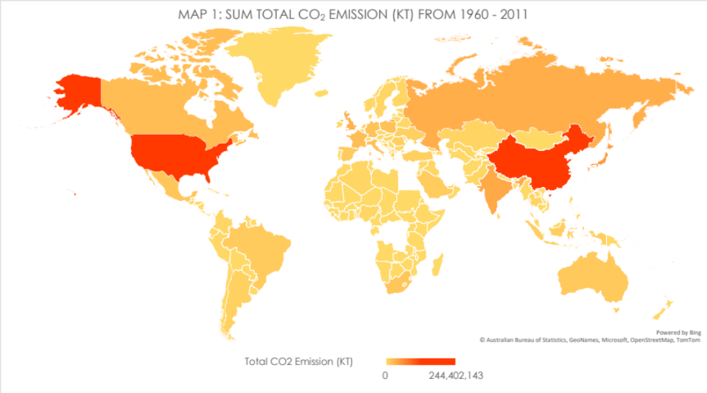
Global Total Sum of CO₂ Emissions per Capita
As the exploration continues, one aspect that needs to be taken into consideration is understanding how countries release CO₂ in relationship to their population size. Map 2 shows other key players coming into the picture. A total of 39,193.279MT CO₂ per capita was released into the atmosphere during this period. Countries such as Qatar (2,830MT), UAE (1,656MT) and Kuwait (1,466MT) emerge as top contributors making up approximately 15% of the global total per capita.
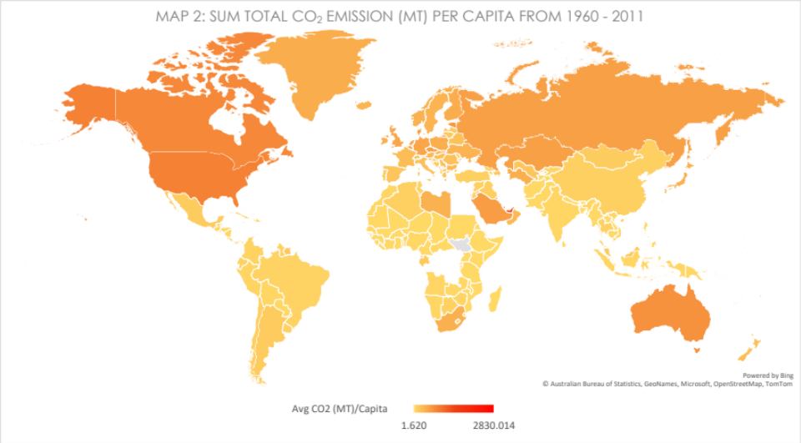

Average CO₂ Emission/Capita by Region
There are seven regions that were identified in this dataset. North America leads the average CO₂ emission per capita. Middle East & North Africa, and Europe & Central Asia follow.
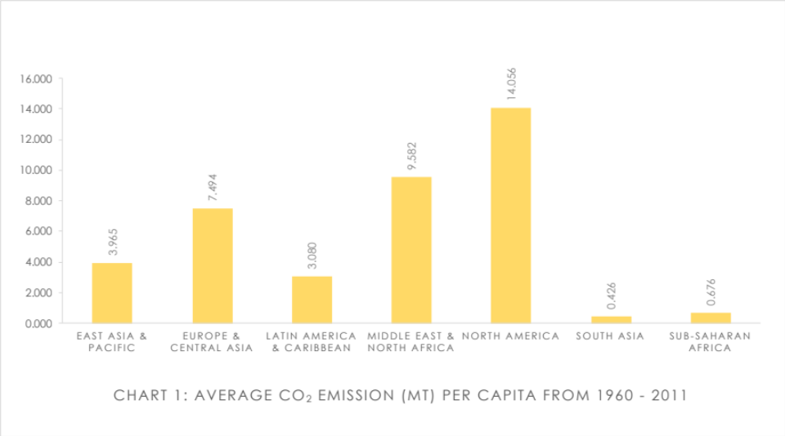
Another key factor is to assess the average global CO₂ emissions: The North America
region lead the rest of the globe in this aspect. This is due to the fact that this region predates CO₂ emissions in the late 20th century before countries in the Middle East and Central Asia joined the rest of the developed world. Chart 2 below indicates this stark difference.
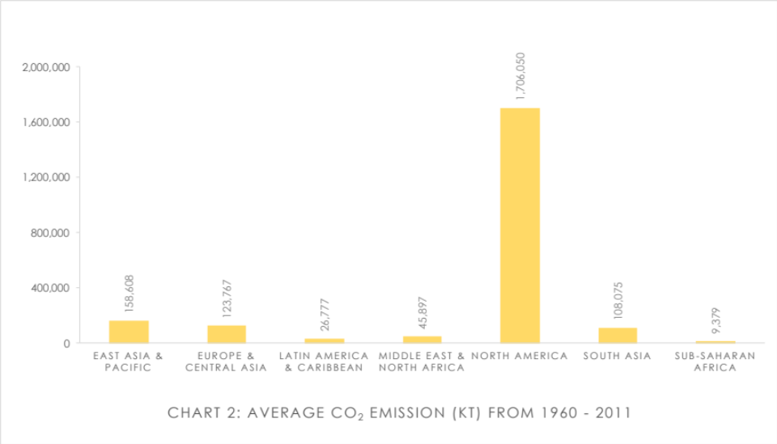
However, Chart 3 below provides insight to how East Asia & Pacific, and Europe & Central Asia regions have added to the global sum due to their drastic emissions increase.
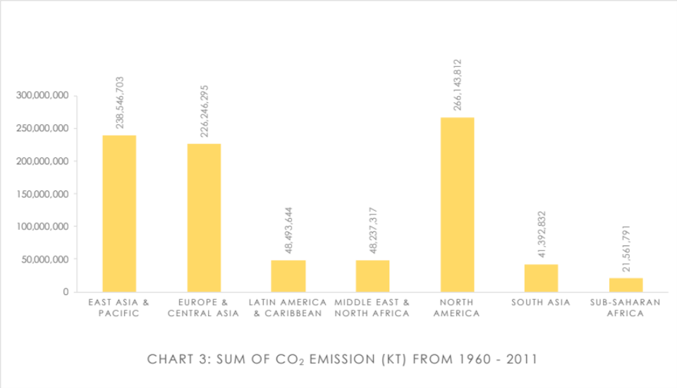
The best way to understand how up and coming developing countries changed how these regions’ CO₂ emissions changed is the chart below: Chart 4. It shows how each region’s percentage to the global emission changed over the decades.
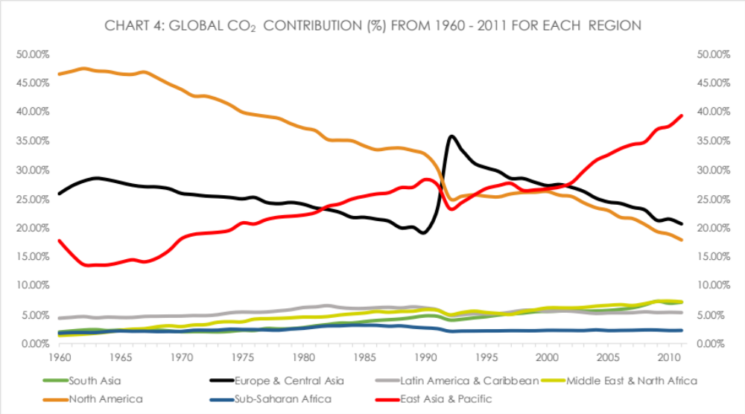
North America started off as a region leading the globe in CO₂ emissions. However, its share started to shrink as East Asia & Pacific region kept on contributing more—which doubled by 2011. Relatively, other regions either recorded a very slow increase or remained about the same.
Global CO₂ Emission Trend
One thing is undoubtedly clear; CO₂ emission globally had continued to increase as countries strive to ensure development and industrialization. Chart 5 paints this reality vividly.
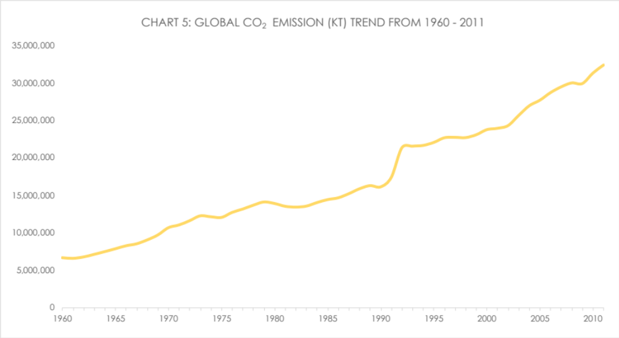

Conclusion
The World Bank dataset of global CO₂ emission from 1960 to 2011 showcases that the North America region had contributed significant sum total amount of carbon dioxide. The United States appears to have a big share for this region. However, other small countries such as Qatar, UAE, and Kuwait also contribute significantly—even lead the average CO₂ emission per capita—despite their small populations and land masses.
The percentage of East Asia & Pacific region’s contribution to the global sum total of CO₂ emission has increased drastically over the decades. Another key element this exploration brought to the forefront was that the amount of CO₂ emission has increased by about 5 times between1960 and 2011. As the globe attempts to addresses climate change trends, reducing greenhouse gases such as carbon dioxide is very vital. In order to do that, understanding how each country and region had contributed to the matter would help hold stakeholders accountable. Furthermore, it offers insight as to how to set goals to curb the ever-growing production of such gases.

References
World Development Indicators | DataBank. (n.d.-b). Retrieved September 29, 2022, from https://databank.worldbank.org/reports.aspx?source=World-Development-Indicators

(World Development Indicators | DataBank, n.d.-b)

